**PDF Active-Reading Assistant  
Initial Project Plan**

Ryan Helms (rh), William Qiu (wq), Nikhar Ramlakhan (nr),Abie Safdie (as), Caleb Sutherland (cs)

4-12-2024 - v1.02

**Table of Contents**

1. Project Plan Revision History 1

2. Management Plan 2

2.1. Team organization 2

2.2. Work division amongst members 2

2.3. Decision making protocols 2

2.4. Team meetings and communication 2

3. Work breakdown schedule 3

3.1. Milestones 3

3.2. Project Schedule 3

3.3. Project Gantt Chart 4

4. Monitoring and reporting 5

4.1. Individual progress monitoring 5

4.2. Project progress monitoring 5

5. Build plan 6

5.1. System build plan 6

5.2. Explanation of system build plan 6

5.3. Risks and risk reduction strategies 7

6. Acknowledgements 7

# 1. Project Plan Revision History

**Date Author Description**

**————— ——— ————————————————————————————**

4-10-2024 nr Created the initial document.

4-11-2024 rh Added project Gantt chart.

4-12-2024 team Finalized the initial document.

4-25-2024 cs Revisions for final project plan

# 2. Management Plan

## 2.1. Team organization

The team consists of Ryan Helms, William Qiu, Abie Safdie, Caleb Sutherland, and Nikhar Ramlakhan, all computer science students in CS 422. Each member contributes to both technical and organizational aspects of the project. Our team is structured to ensure collaboration and expertise in all aspects of the project. Nikhar Ramlakhan will also oversee project management and ensures adherence to documentation.

## 2.2. Work division amongst members

Tasks are allocated based on individual strengths and interests, ensuring a balanced workload and diverse skill set utilization. Nikhar and William focus on system setup and backend development, while Abie, Caleb, and Ryan handle user interface design and front-end development. Collaboration and cross-functional involvement are encouraged to foster a holistic understanding of the project.

## 2.3. Decision making protocols

Decisions are made collaboratively, with input from all team members. Major decisions require a super-majority vote (3 out of 5) to ensure consensus and representation of all perspectives. Major decisions will be documented and signed / initialed by all team members to ensure that a record is kept in case any future disputes or disagreements.

## 2.4. Team meetings and communication

Communication is facilitated through a Discord channel and a WhatsApp group channel for any group discussions outside of meetings. Members are expected to communicate respectfully and within designated hours (8:00am to 10:00pm). In-person meetings are held at the Allan Price Science Commons Library on the following dates and times:

* Monday, 8 April | 6:00pm to 8:00pm
* Friday, 12 April | 4:00pm to 5:00pm
* Monday, 15 April | 6:00pm to 8:00pm
* Friday, 19 April | 4:00pm to 5:00pm
* Monday, 22 April | 6:00pm to 8:00pm
* Friday, 26 April | 4:00pm to 6:00pm
* Additional meetings can be organized at least 24 hours in advance.

# 3. Work breakdown schedule

## 3.1. Milestones

|  |  |  |
| --- | --- | --- |
| **#** | **Projected Milestone** | **Projected Date** |
| 1. | Initial Project Plan, SRS and SDS | 04/12/2024 |
| 2. | Server and Database Setup | 04/16/2024 |
| 3. | GUI Development and PDF Viewer Implementation | 04/16/2024 |
| 4. | Integrate Database with ix-dev | 04/17/2024 |
| 6. | User Account Selection and Server Setup Prompt | 04/18/2024 |
| 7. | Note Hiding and Displaying Buttons | 04/20/2024 |
| 8. | Data Storage and Retrieval Note | 04/21/2024 |
| 9. | Implement Hierarchical Notetaking | 04/22/2024 |
| 10. | SQ3R Note-Taking System | 04/22/2024 |
| 10. | Pre-loaded PDFs and Sample Data | 04/23/2024 |
| 11. | User Profile and Server Integration | 04/24/2024 |
| 12. | Organization, Planning and Technical Document | 04/25/2024 |

## 3.2. Project Schedule

Following the above milestones, the project schedule can be derived as follows:

|  |  |  |
| --- | --- | --- |
| **Milestone** | **Projected Date** | **Assigned Member(s)** |
| Initial Project Plan, SRS and SDS | 04/12/2024 | team |
| Server and Database Setup | 04/16/2024 | wq, nr |
| GUI Development and PDF Viewer Implementation | 04/16/2024 | rh, as, cs |
| Integrate Database with ix-dev | 04/17/2024 | rh,as |
| User Account Selection and Server Setup Prompt | 04/18/2024 | as, cs |
| Note Hiding and Displaying Buttons | 04/20/2024 | wq, nr |
| Data Storage and Retrieval | 04/21/2024 | wq, nr |
| Implement Hierarchical Notetaking | 04/22/2024 | rh, as, cs |
| SQ3R Note-Taking System | 04/22/2024 | rh, cs |
| Pre-loaded PDFs and Sample Data | 04/23/2024 | rh, as, cs |
| User Profile and Server Integration | 04/24/2024 | wq, nr |
| Organization, Planning and Technical Document | 04/25/2024 | team |

## 3.3. Project Gantt Chart

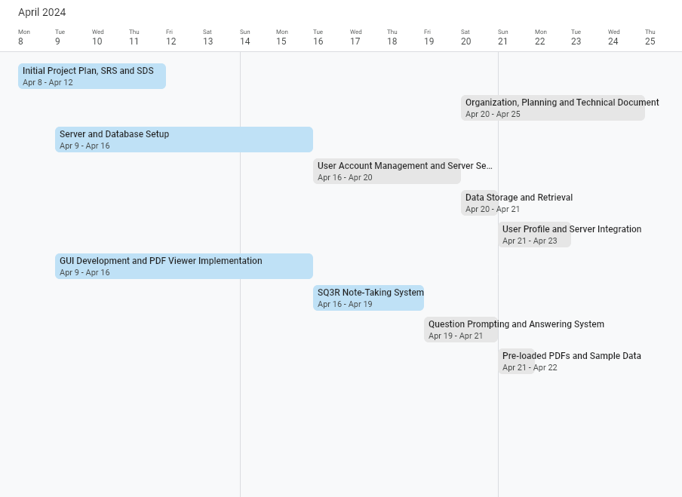

# 4. Monitoring and reporting

## 4.1. Individual progress monitoring

Individual progress will be primarily monitored through the GitHub repository and the developer log / document log markdown file. Each team member is responsible for regularly updating the developer log / document log with their contributions, changes made, and revisions. This log will serve as a central hub for tracking individual progress and documenting project developments.

Regular team meetings will be held, providing an opportunity for members to report their progress, discuss any challenges or roadblocks, and coordinate on tasks. At the beginning of each meeting, members will provide updates on their individual contributions, which will be documented in the developer log / document log.

## 4.2. Project progress monitoring

Project progress will be monitored through various channels to ensure alignment with the project plan and objectives:

* Documentation Updates: Documentation, including the project plan, SRS, and SDS, will be continuously updated to reflect project progress and any changes or refinements made. During team meetings, documentation will be reviewed and revised as necessary to ensure accuracy and alignment with project developments.
* Communication Channels: WhatsApp and Discord will serve as additional avenues for minor updates, progress reviews, and ad-hoc discussions among team members. While major updates and progress reports will be documented in the developer log / document log, these communication channels will facilitate real-time collaboration and information sharing.
* Gantt Chart: A Gantt chart will be developed as part of project monitoring, providing a visual representation of project timelines, milestones, and dependencies. The Gantt chart will be updated regularly to reflect progress and any adjustments to the project schedule.

# 5. Build plan

## 5.1. System build plan

1. Initial Setup
   * Establish development environment
   * Set up GitHub repository
   * Create project files and directories
2. Backend Development
   * Implement the server for storing program data
   * Develop system for storing user data and profiles
   * Set up database for storing user information
   * Create system to prompt user inputs for server setup
3. Frontend Development
   * Design and develop GUI for accessing PDF files and parsing text
   * Implement hierarchical SQ3R structure for capturing user notes
   * Develop system for hiding and unhiding notes
   * Create system for cycling through questions in user notes
4. User Management and Authentication
   * Create system for managing user accounts and profiles
   * Develop functionality for pre-defining user accounts
5. Integration and Testing
   * Integrate frontend and backend components
   * Conduct testing to ensure functionality and reliability
   * Address any bugs or errors identified during testing
6. Deployment and Release
   * Prepare system for deployment to production environment
   * Develop deployment scripts and procedures
   * Release system to end-users
7. Sample Data Preparation
   * Generate pre-loaded complete notes
   * Populate database with sample data for testing and demonstration purposes

## 5.2. Explanation of system build plan

1. Modularity and Scalability: Breaking the system into distinct components allows for modularity, making it easier to manage and scale the project. Each component can be developed, tested, and deployed independently, reducing complexity and facilitating future updates or expansions.
2. Clear Functionalities: Each step in the build plan corresponds to a specific functionality or feature of the PDF Active-Reading Assistant. This approach ensures clarity and focus, enabling the team to prioritize tasks effectively and deliver incremental value to users.
3. Risk Management: By identifying and addressing potential risks early in the development process, the build plan aims to mitigate project risks and uncertainties.
4. User-Centric Design: The build plan prioritizes functionalities that directly impact the user experience, such as GUI development, note-taking features, and PDF parsing capabilities. This user-centric approach ensures that the system meets the needs and expectations of its intended users, enhancing usability and satisfaction.
5. Progressive Enhancement: The build plan follows a progressive enhancement approach, starting with essential functionalities and gradually adding more advanced features. This incremental development strategy allows for early feedback from developers and users, enabling iterative improvements based on real-world usage and feedback.

## 5.3. Risks and risk reduction strategies

1. Research and Prototyping: Before proceeding with development, conduct thorough research and prototyping to explore potential solutions, identify technical challenges, and validate assumptions. This helps mitigate risks associated with unknowns and uncertainties.
2. Regular Testing and Quality Assurance: Implement robust testing processes, including unit tests, integration tests, and end-to-end tests, to identify and address bugs, errors, and inconsistencies. Prioritize quality assurance throughout the development lifecycle to ensure the reliability and stability of the system.
3. Continuous Communication and Collaboration: Foster open communication and collaboration within the team to address challenges, share insights, and align on objectives. Regular team meetings, progress updates, and discussions help identify and resolve issues promptly, minimizing the impact on project timelines and deliverables.

# Acknowledgements

The content of this document is inspired by the Project 1 Evaluation Criteria provided by Prof. Anthony Hornof.

This document template is built and derived from SRS/SDS template provided by Prof. Anthony Hornof. Additionally, it builds on a document developed by Stuart Faulk in 2017, and on the publications cited within the document, such as IEEE Std 1016-2009.